* Email dan to follow up on the air/water membrane
  + Increased liability with water??
* Ask about using a wheatstone bridge?
* Flex sensor
  + <http://www.taiwanalpha.com/downloads?target=products&id=248>
  + 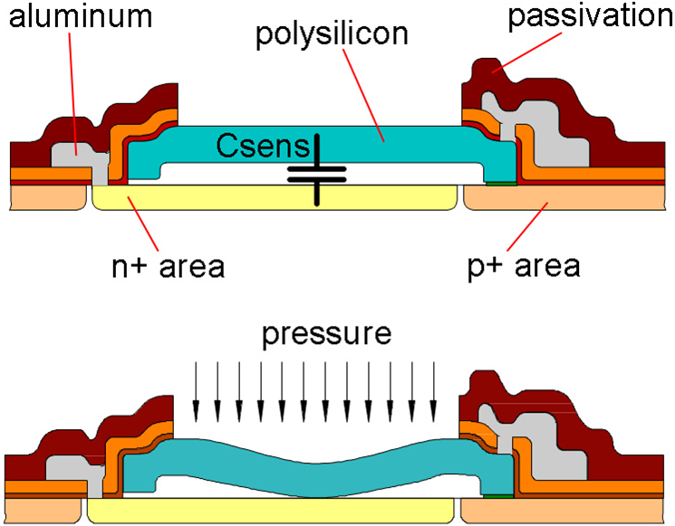
  + 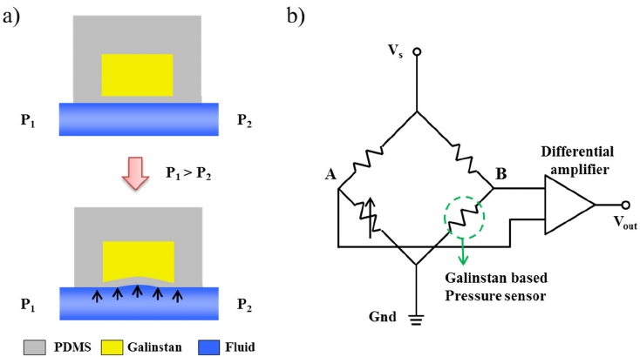
  + 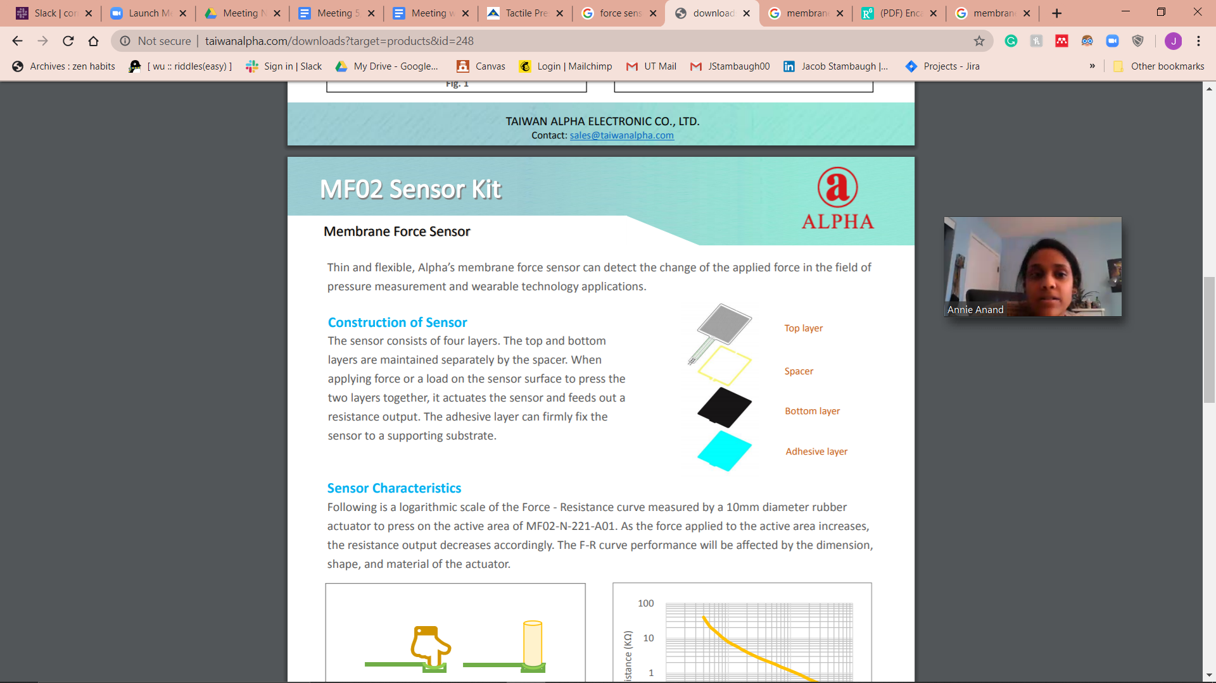
  + In case filter stuff doesn’t work out
* Could we possibly just put this on the tubing since its water proof already?
* +
* Can we just add a filter and figure out the pressure difference?
  + Use a barometric sensor to measure and figure out and not actually implement it in device.
* Place filters upstream so filtered air through system
* Modular design
* Making filters? 8 year lifetime for a hepa filter

Email Draft:

Hi Dr. Dan!

Hope you’re doing well. We wanted to send a follow-up email based on discussions about what we heard from you in the meeting we had. We were thinking about it more, and weren’t completely sure about the implementation of a filtering system with the air/water membrane. Would it be possible to just place the pressure sensor at the beginning of the tubing so the entire system just has filtered air going through it?

We figured that adding an entire contraption may be more trouble than it's worth since we would have to do this for all four tubes. We will have one pressure sensor for each tube as well, so there wouldn’t be a risk for contamination between tubes as long as the check valves are put in place. So basically we’d have a filter right after the air hits the pressure sensor, and we’d experimentally figure out if that addition of the filter has any effect on the overall pressure readings for the tube/how much it's affected by.

Finally, we were thinking of another idea of using a wheatstone bridge sensor in place of our existing sensor? --Add detail here, since i’m not fully sure how to explain--

--add part about flex sensor?--